In the video, we focus on what a Pre-Shot Routine might look like, and how we like to line up a shot and just “go”. In this Free Download we’d like to tell you all the details of ‘what a Pre-Shot Routine is’, ‘why you need one’, and ‘how to build your own’, because there’s just a little bit more to consider on every shot than the video may suggest. Developing your own Pre-Shot Routine will help you focus on what you want the ball to do, and NOT what your body or swing needs to do. We always say, when you ’play golf’ you shoot your lowest scores, and when you ‘play golf swing’ you talk about what your lowest scores ‘could have been’, which is a lot less fun.

What is a Pre-Shot Routine?

A Pre-Shot Routine is the process you take once you get to your golf ball and decide to hit a golf shot. It doesn’t start until the fairway or green is clear, and you are able to hit a shot. But there are things that need to happen before the Pre-Shot Routine. Let’s go over what typically happens Before and During a Pre-Shot Routine.

Before the Pre-Shot Routine
- Observe – As you’re walking to your golf ball, you’ll want to see where the hazards are, if there’s any OB between you and the hole or beyond the hole, where the flag is on the green and what the wind & weather conditions might be.
- Arrive – Set your bag down a safe distance from the ball so that it can’t possibly fall on your ball and cause a penalty stroke.
- Measure –Use sprinklers, markers, or a laser range finder to get your number. Usually, you can get a solid number with golfers still on the green.
- Strategize – This is where you take all the information you’ve gathered and make a decision on where you want to hit the ball, and what type of shot you want to play (high, low, draw, fade, etc.), and what club you are going to use.
- Commit – This is where you pull the club from your golf bag and start your Pre-Shot Routine. If you were previously unsure if you needed your 160-carry club to hit it 160, or if you need your 175-club because of wind, this is not the time…go back to step 4 and figure it out.

Pre-Shot Routine

Once you Commit #5, you start your Pre-Shot Routine, and go through the same motions every time. Now, we don’t want to be too dogmatic and say take exactly three practice swings, and then ‘Go’. Take as many as you need to feel the motion you’d need to take that particular shot. What I mean by that is; if you want to hit a low shot, maybe you feel like your arms stop at shoulder height on the Finish, or if you want to hit a cut shot, maybe you feel like you hold off the face a touch more. Whatever your feel is, just let this part happen and feel the shot you want to take?

The timing of when you arrive to your ball, start your Pre-Shot Routine, and send the golf ball on its way should be the same for every shot. It’s something you will need to practice, and it’s something that you’ll need to be comfortable with. Over time, it will become second nature and you won’t even think about it. But first, you have to develop your own process which we will walk you through later on in this guide.

Examples from the Pros:

Let’s take a look at some Pre-Shot Routine footage from the 2019 British Masters of Trevor Immelman (2008 Masters Champion) and Matthew Fitzpatrick. Click on each picture to start the video. These guys did these same exact Pre-Shot Routines for every shot on every hole.
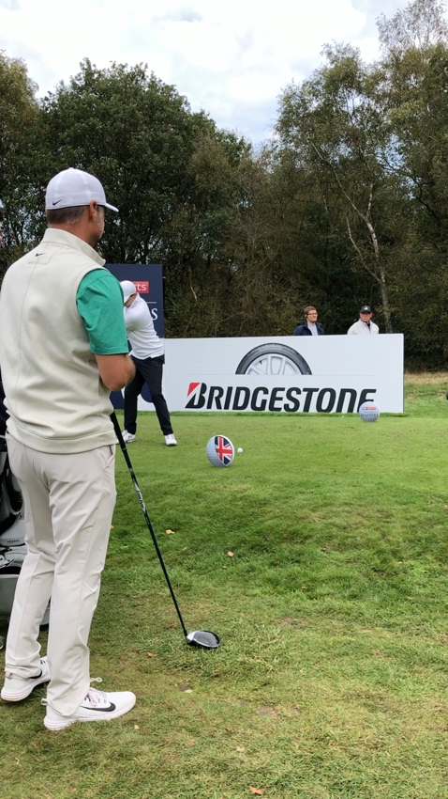
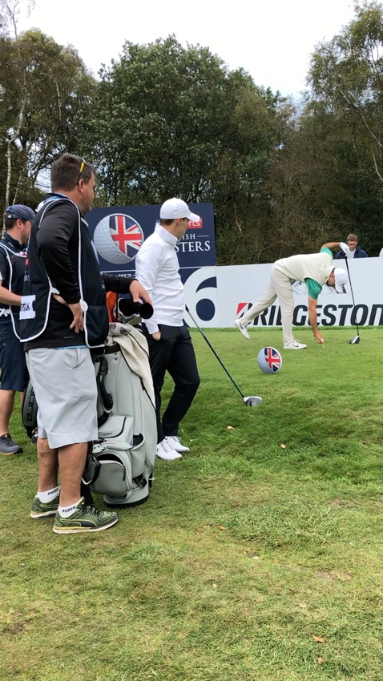

Trevor Immelman | Matthew Fitzpatrick
- Tees up the ball  - Grabs some grass & throws it to gauge wind  - Picks a target and points driver with right hand holding driver  - Takes slow practice swing  - Stands behind the ball on his line and looks down range to pick a specific target  - Imagines the ball going towards target (while behind the ball)  - Walks to get into a setup while holding club in left hand  - Puts club down first and then gets his stance width  - Picks up club and adjusts his stance  - Takes one slight waggle back  - Takes club back to 9:00 mimicking his takeaway  - Puts club back down  - Picks club up in mini waggle  - Puts club on ground  - Go – hits shot | - Tees up the ball and walks behind the ball  - Imitates Impact and getting there  - Takes Swing with short follow through  - Takes Swing with full follow through and steps back along his line  - Hits club down on tee-box with his left hand  - Walks into shot holding club in his left hand  - Places club down with his left hand and narrow stance  - Widens stance while shifting feet slightly  - Takes mini waggle back  - Looks at target  - Go – Hits shot

Why do we need a Pre-Shot Routine?

This is an unscientific answer with absolutely no research but it works; We think it simply helps take your mind off any mechanical thoughts and gets you in a comfortable place to hit a golf shot. You are seeing a target and imagining a ball going directly at the target, you are feeling what the shot feels like when you waggle, you are feeling where your feet should be in relation to your target, and you aren’t thinking about swing plane, where your arms should be, what your hands should be doing, casting, slicing, etc. You feel these things during the Pre-Shot Routine, and then you react and ‘Go!’.

Think of hitting a golf shot like signing your name or riding a bicycle…you just ‘do’ those things and don’t think. Because golf is so difficult, we end up thinking a lot of the time when we should be doing, so we need a routine to take our mind off the thinking and program our brains to simply react. The Pre-Shot Routine is the programming you need to just react and ‘Go!’. Playing golf is not the time to change things and think about what swing changes you need to make, it’s the time to enjoy the outdoors, get some exercise, and have some fun. Whatever swing you have is the swing you’re going to have on every shot. If you always hit a slice, thinking about how not to hit one on the golf course isn’t going to prevent the slice, so just play with it and concentrate on your target and having fun. Save the thinking for your home training or the practice tee, and your scores will drop for sure.
How do you build your own personalized Pre-Shot Routine?

Let’s look at how I (Matt) built my Pre-Shot Routine between rounds at a four-day tournament. Back when I was at the beginning of my golf improvement journey, I played in a tournament with Tim down on the Monterrey Peninsula. At the time, I had been working with Tim for less than a year and had brought my handicap from 24 down to 12 during that time. So, while I felt pretty good with my game at the time, I ended up playing an awful round of golf on the first day of the tournament. After the round, we are on the range, and Tim was thinking that I was thinking too much and suggested we might need to tweak something. He asks me, “what’s your Pre-Shot Routine”? I said, “What’s a Pre-Shot Routine?”. I didn’t have one. Tim says, “Oh Boy, no wonder why you played awful today, you were thinking too much out there.” So, for the next hour, Tim helped me build one; here’s what we did once I Commit #5 to a shot and it’s pretty much the same today as developed years ago.

Matt’s Pre-Shot Routine:

- Pick a Target, something very specific - Instead of simply saying, ‘middle of the fairway’, I might say to myself ‘the left edge of the bunker that is just beyond the fairway’, or ‘the right edge of that hanging branch of the tree in the distance’. Whatever I pick, I try to make it as specific as possible.
- Take one or two practice swings from behind the ball while looking at the target – I usually have one feel I’m trying to nail down. Recently I have been pausing at the top so I can feel the top of the swing. I pause because I tend to get long, and feeling the top while watching the target helps program my brain to stay short and compact when I ‘Go!’. During this part of my Pre-Shot Routine, I am usually fine tuning my SetUp for the lie I have if I’m in a fairway. I want to see if I’m uphill or downhill, or on a side lie so I can adjust my Set Up and feels slightly for the slope or possibly wet or hard fairway conditions. This happens very quickly and is based on feels and experience.
- Pick an Intermediate Target – A leaf, brown grass, or sprinkler, anything that I can see with a slight pan left of my eyes, roughly 3 feet from the ball. I do this from behind the ball so I know that the Intermediate Target is in line with my actual Target. This gives me confidence that if I hit the ball over that leaf, it will be on Target the whole way.
- Step into my shot with an open stance, both hands on the club, and align the clubface perpendicular to my Intermediate Target – This is my key to proper alignment and it’s as simple as lining up my clubface with something that is a mere 3 feet away.
- Square my stance (based on the shot shape I’m trying to produce) to my Intermediate Target and get a comfortable Set Up
- Take 2 – 3 Takeaways to make sure the club is staying outside my hands back – This can change to a tiny waggle, or maybe even a full backswing depending on what I’m feeling. The point is to have some movement for me.
- Take a relaxed grip where I take my right thumb, forefinger, and pinkie off the club briefly while I hover the club over the ball. This gets me ready to pull-the-trigger.
- Place the club behind the ball
- Go!

